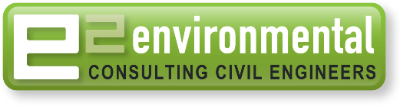
POSITION AVAILABLE: Water Resources/Civil Engineer: Intermediate/Senior

We require an Intermediate or Senior Water Resources Engineer for our civil and land development projects.

Tasks / Skills required:

- 3 waters engineering with a focus on stormwater management including design of treatment and attenuation systems
- Hydrology/hydraulic modelling
- River Engineering
- Land Development engineering: design, approvals at the Local Council or Regional Council level, contract and construction management
- Technically minded and practical. Ideally, 7-15 years work experience, preferably in New Zealand.
- 12d or Civil3d, CAD drafting related to land development, earthworks, stormwater basis or wetlands experience an advantage.
- Must be client focused and organised, with good time management to meet project timeframes and quality standards.
- Have good communications skills, written and verbal.
- Can operate in a team environment and work collaboratively with other staff members.
- Must hold New Zealand Work Visa.
- Remuneration to suit experience and skill level.

e2Environmental Ltd: About Us:
e2 is a medium sized business with offices located in Christchurch, Blenheim and Ashburton.
We specialise in 3 waters; Wastewater, Stormwater, water supply and land development.
For more information visit our website;
https://www.e2environmental.com/

Applications or expressions of interest - please contact:
Andrew Tisch (Director)
hr@e2environmental.com
PH: 021 0655 471

